Secretary, DARE and Director General, ICAR visited ATARI, Kanpur

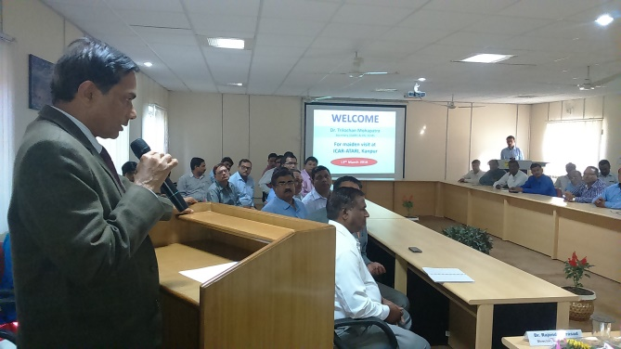
Dr. Trilochan Mohapatra, Secretary, DARE and DG, ICAR visited ICAR-ATARI, Kanpur on 13/3/2016. While addressing the gathering of scientist and staff of ATARI, and the scientists from the Krishi Vigyan Kendra of Uttar Pradesh, Dr. Mohapotra appreciated the efforts of KVKs at the district level for doing the job of technology assessment and frontline demonstration. However, he reiterated that training is the most important component for any KVK and it has to made more effective by linking the trained farmers to various value chains of a given commodity or enterprise in which the entrepreneurial training was imparted.

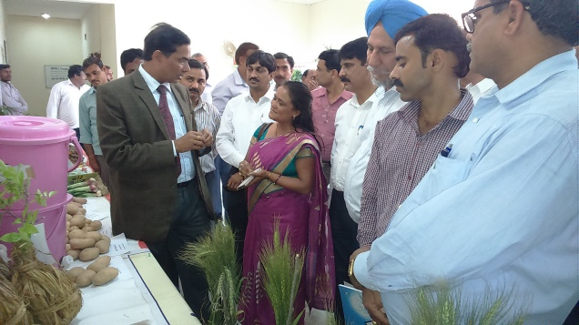
High suggested three guiding framework for effective performance of KVK. Firstly, every KVK must focus on bringing more visibility of their works in the district. The use of mass media – both print and electronic may be best means in this direction, he further suggested. Secondly, there should be tripartite MoU between the KVKs, ATARI and the Heads of state agricultural and allied departments for convergence and out-scaling of at least the five technologies assessed as most appropriate for every district by the respective KVKs. Thirdly, every KVK must be responsive to any external source of resources for executing their activities.

Hon’ble DG very specifically hinted that promotion of pulses and oilseeds related varieties and area specific packages should be our thrust area for the coming five years. He urged the KVK scientists to saturate their respective districts with the improved varieties of pulses and oilseed crops so that country may witness pulse revolution in real sense. He also took keen interest in the technologies/crop varieties, value added products, farmer friendly literature and the low cost water purifying system displayed by the participating KVKs in the exhibition arranged at ATARI, Kanpur. On this occasion, Hon’ble DG, ICAR also released the Annual Action Plan (2016-17) of the KVKs of Uttar Pradesh and Uttarakhand and Year Planner of ICAR-ATARI, Kanpur

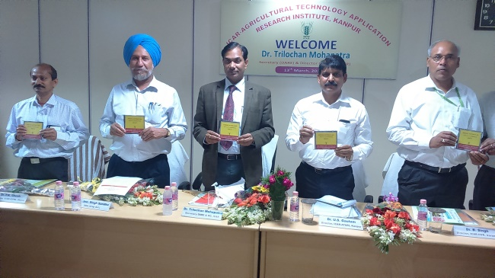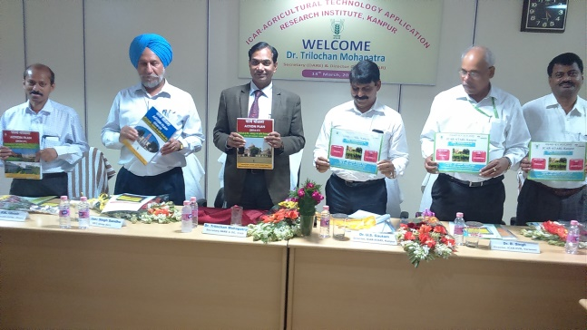

Dr. JS Sandhu, DDG (Crop Sciences) also addressed the audience and focused on bringing more visibility in the works of KVKs. He suggested that only the new technologies and crop varieties of NARS may be utilized in their mandated programme.

On this occasion, Dr. US Gautam, Director, ICAR-ATARI, Kanpur shared some of the relevant financial and administrative issues related to various host institutions for their redressal by the higher authority of ICAR so that KVK may perform best of their capacity.

Directors of ICAR-IIPR, Kanpur; ICAR-IGFRI, Jhansi; ICAR-IIVR, Varanasi, ICAR-IISS, Mau and ICAR-ATARI, Jodhpur were present on the occasion.

